®
LIFE & LIMB GEL

THERAPY PRODUCTS

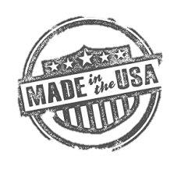

The ONLY wraps designed to contour
to the body for a perfect fit

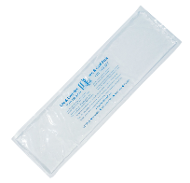
Experience the Difference!
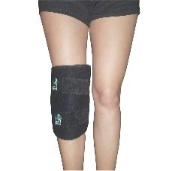

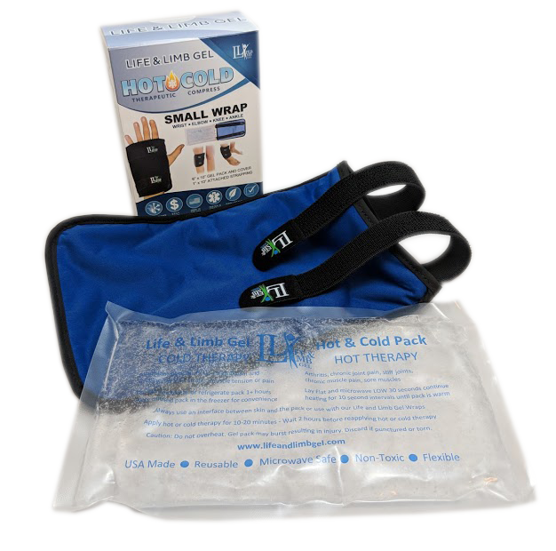
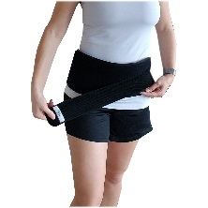
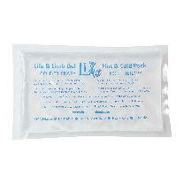
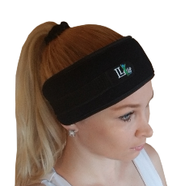

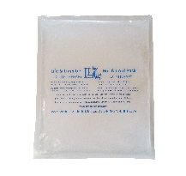

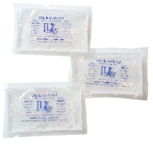
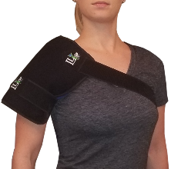

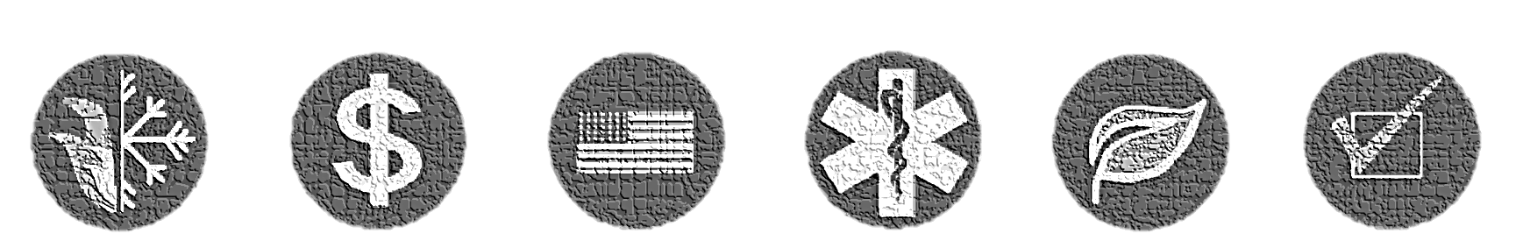

BEST
VALUE
MICROWAVE SAFE
COLDER THAN ICE
USA BASED
COMPANY
TESTED &
APPROVED
NON-TOXIC
ECO-FRIENDLY
SATISFACTION GUARANTEED

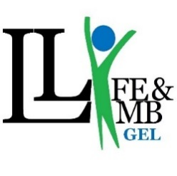
®
Web: www.lifeandlimbgel.com
E-mail: info@lifeandlimbgel.com
Phone: (360) 909-2845
Fax: (503) 419-9871
Mail: 399 S Razor Clam Drive SW
Ocean Shores, WA 98569

Life & Limb Gel
Hot & Cold Therapy that contours for a perfect fit
Wherever you need relief, Life and Limb Gel offers state-of-the-art hot and cold therapy products that are sure to meet your needs and budget. Hot therapy can help soothe and relax sore muscles, can reduce arthritic joint pain, and can stimulate blood flow to accelerate the healing process. Cold therapy is an excellent way to treat acute sprains and strains and treat muscle tension, pain, and spasm. Cold therapy also helps reduce injury-related pain and swelling. When it comes to treatment, there is no comparison to Life and Limb Gel.
- ERGONOMIC DESIGNS - Designed, tested, and approved by medical professionals
- MADE IN THE USA - Our premium quality gel packs and wraps are handmade in the USA
- PREMIUM MATERIALS – Non-toxic, environmentally safe, and hypoallergenic material
- PROPRIETARY FORMULA - Our proprietary gel is non-toxic and stays flexible while frozen
- SAFE AND EFFECTIVE - Suitable for both chronic and acute conditions and safe for daily use
- FROST FREE WRAPS - Our wraps use a unique inner material that prevents condensation
- SATISFACTION GUARANTEED - Our products are backed by a 100% guarantee

COMPARE US TO OTHER TOP SELLING BRANDS

 | LIFE & LIMB GEL |  | BRAND W | BRAND X | BRAND Y | BRAND Z
1 YEAR WARRANTY
EASY TO CLEAN
ECO-FRIENDLY PLASTIC

FLEXIBLE WHEN FROZEN

HOT AND COLD THERAPY
LONGER THERAPY TIME

MISSION TO GIVE BACK

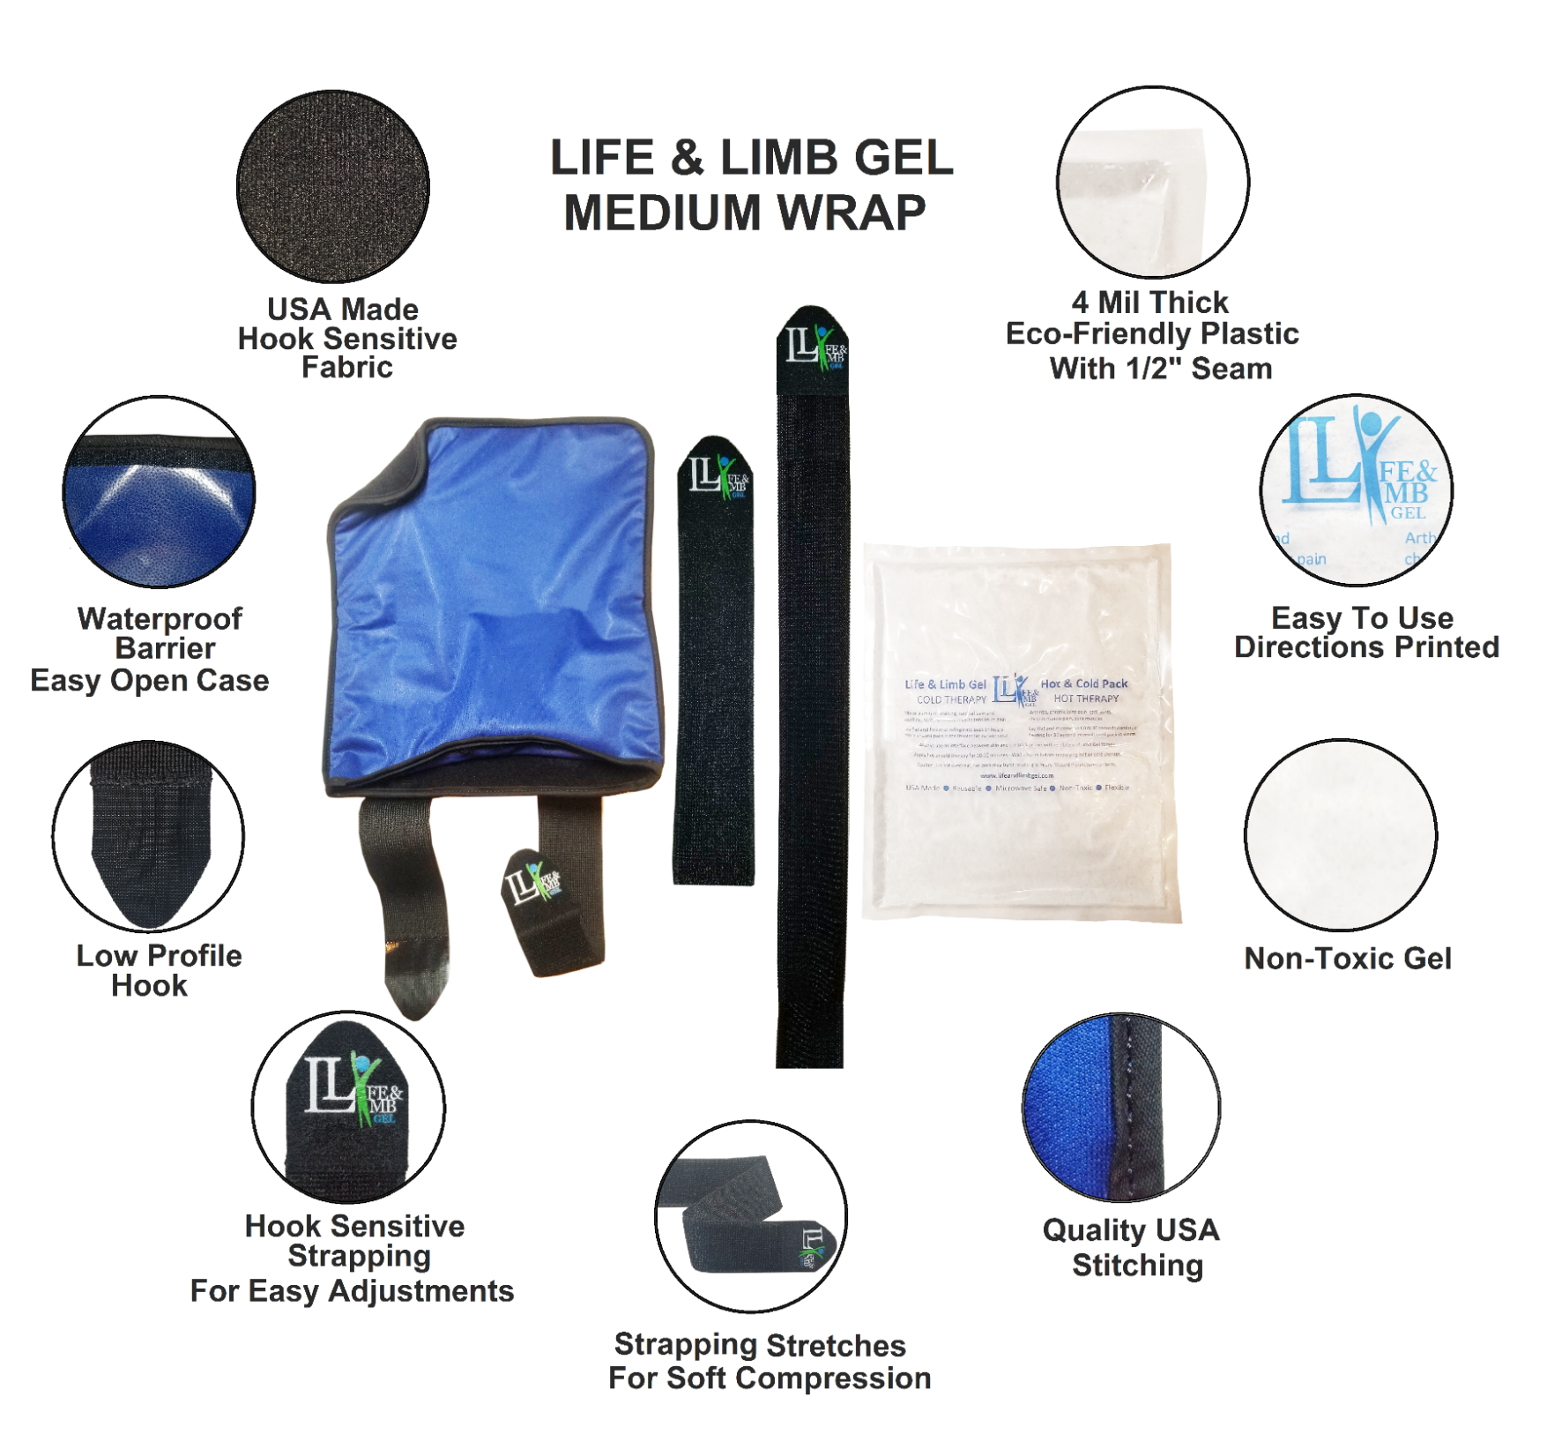

Experience the Difference!

Our unique designs allow one product to provide a custom contoured fit wherever you need!

OR

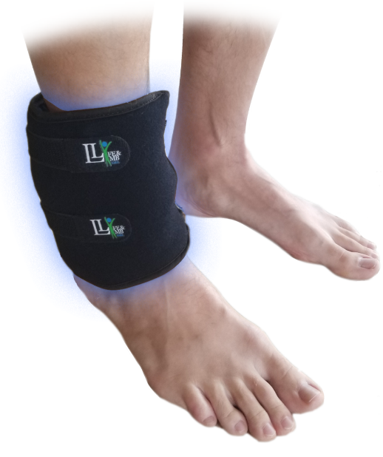
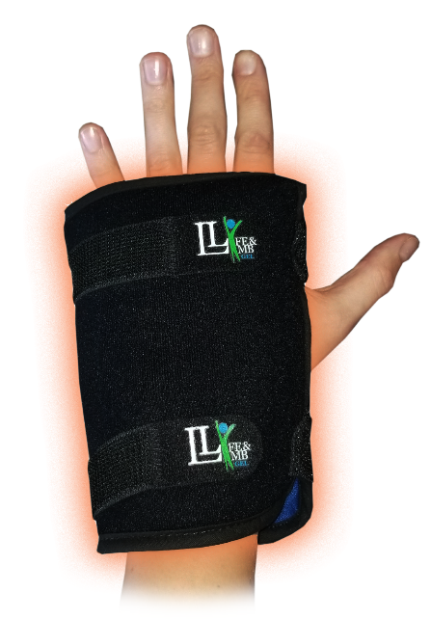

One Product - Many Possibilities
Use hot BEFORE a workout to warm up muscles, or cold AFTER a workout
or sports injury for faster recovery
Our elasticized strapping provides gentle compression to aid in healing
and allow hands-free therapy
Our small wrap fits the wrist, ankle, knee, elbow - a customized fit wherever you need!

Benefits of Cold Therapy Use After Surgery

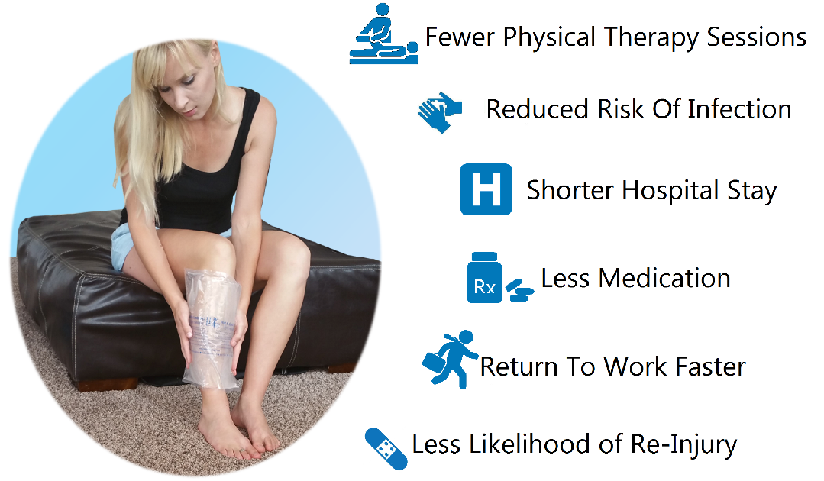

®
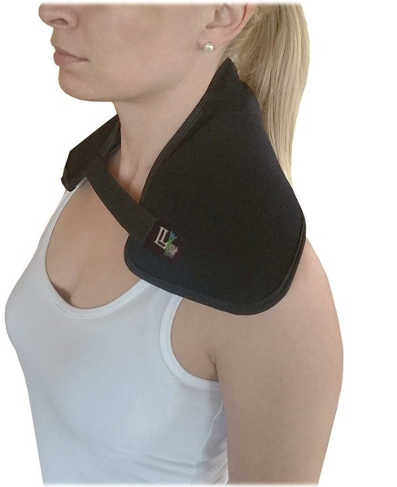  Neck Wrap  6” x 20” washable removable cover  attached 1” x 7” strapping  underarm comfort strap  Flexible When Frozen  Frost-Free Cover  Elasticized Strapping for Easy Adjustments  SKU: 201208 | 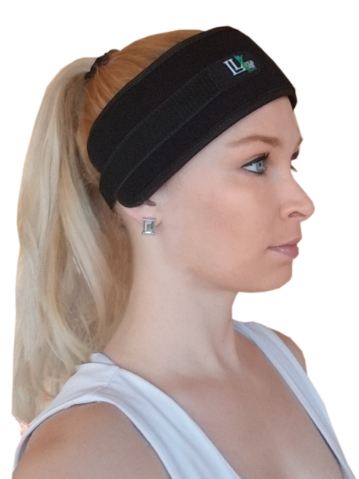  Head Wrap  Headache * Sinus * Patellar Tendon * Toothache  - Includes a washable removable gel pack and  cover with attached 1” x 10” strapping  Fits 5” – 27” circumference  Flexible When Frozen  Frost-Free Cover  Elasticized Strapping for Easy Adjustments  SKU: 201803

Extra Small Wrap  Plantar Fasciitis * Wrist * Pediatrics * Achilles  3” x 15” washable cover  and TWO interchangeable 3” x 5” gel packs  Flexible When Frozen  Frost-Free Gel Pouch  Hook and Loop Closure  SKU: Single Pack 201807 | 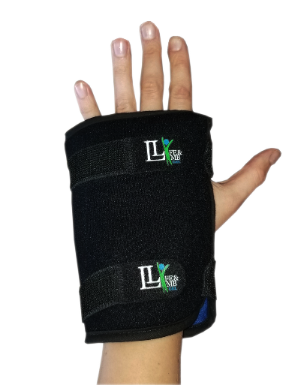  Small Wrap  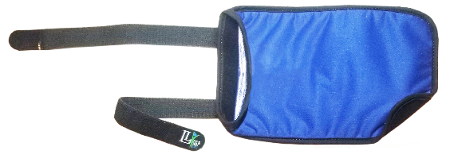  Elbow * Wrist * Ankle * Knee  6” X 10” Includes a washable removable gel pack  and a cover with 1" x 10" attached strapping  Fits 4" - 20" circumference  Flexible When Frozen  Frost-Free Cover  - Elasticized Strapping for Easy Adjustments  SKU: 201208

®
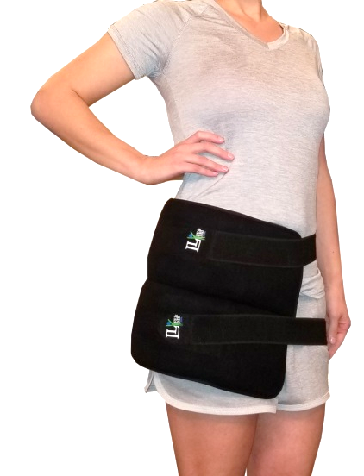  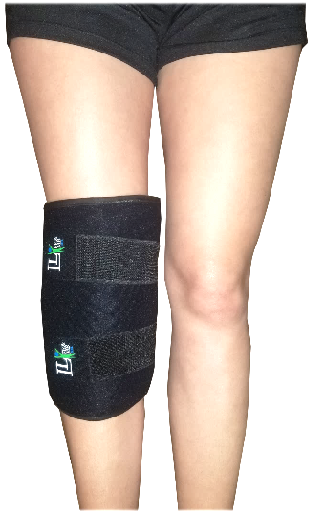  Medium Wrap  Knee * Leg * Arm * Shoulder * Hip  10”x 12” washable removable cover  2" x 12" attached strapping  2” x 12” and 2” x 24” strapping extenders  10” x 12” gel pack  fits 6" – 38” circumference & 50” at hip/chest  Flexible When Frozen  Frost-Free Cover  Elasticized Strapping for Easy Adjustments  SKU: 201204 | 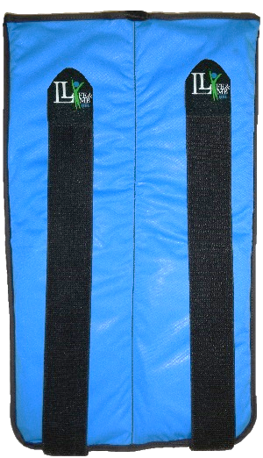  Large Wrap  Knee * Hip * Back * Leg  12” x 20” washable removable cover  2” x 26” attached strapping  Two 6" x 20" Gel Packs  Fits 8" - 50" circumference  Flexible When Frozen  Frost-Free Cover  Elasticized Strapping for Easy Adjustments  SKU: 201201
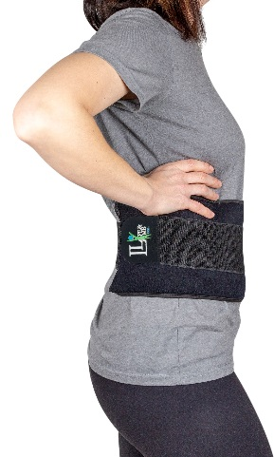  Long Wrap  Knee * Ankle * Back * Hip * Shoulder  6” x 20” washable removable cover  3" x 26" attached strapping  6” x 20” gel insert  Fits 6" - 50" circumference  Flexible When Frozen  Frost-Free Cover  Elasticized Strapping for Easy Adjustments  SKU: 201202 | |  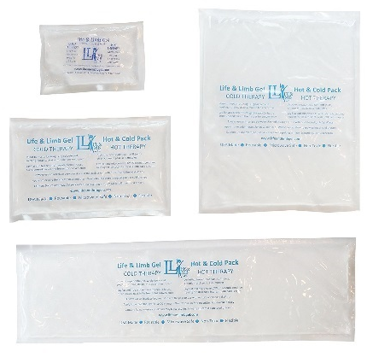  Gel Pack Set  Includes 1 each of:  3” x 5”, 6” x 10”, 6” x 20” & 10” x 12”  Flexible When Frozen  Microwave Safe  Professional Quality  Diverse sizes  Flexible When Frozen  Microwave Safe  SKU: 201310

3" x 5"  Extra Small Gel Pack  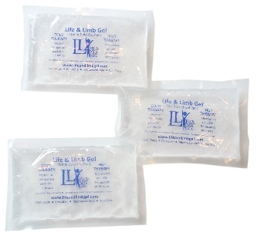  Flexible When Frozen  Microwave Safe  Perfect size for children,  dental pain, nursing mothers,  and minor bumps and bruises  Use with Life and Limb Gel Extra Small Wrap  Available in a 3, 6 or 12 Pack  SKU: 201309 | 6" x 10"  Small Gel Pack  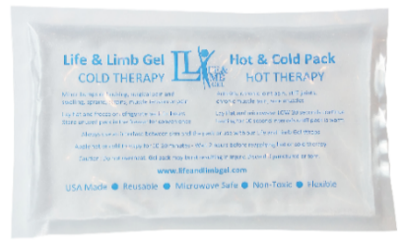  Flexible When Frozen  Microwave Safe  Great size for coolers and lunch boxes  Use with Life and Limb Gel  Small Wrap  Available in a single, double, or 6 Pack  SKU: 201308
10" x 12"  Medium Gel Pack  Flexible When Frozen  Microwave Safe  Use with Life and Limb Gel  Medium Wrap  Available in a single or double pack  SKU: 201304 | 6” x 20”  Extra Long Gel Pack  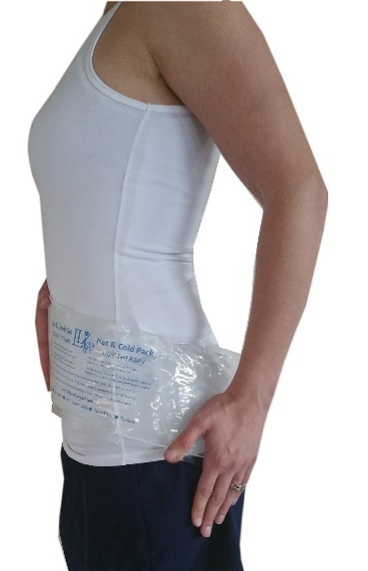  Flexible When Frozen  Microwave Safe  Use with Life and Limb Gel  Large Wrap, Long Wrap, and Neck Wrap  Available in a single or double pack  SKU: 201302
®

®

Product Name | SKU | Wholesale
Neck Wrap | 201206 | $10.00
Head Wrap | 201803 | $6.00
Extra Small Wrap | Single Pack – 201807 | $6.00
 | Double Pack – 201827 | $10.00
Small Wrap | 201208 | $9.50
Medium Wrap | 201204 | $15.00
Large Wrap | 201201 | $19.00
Long Wrap | 201202 | $15.00
3” x 5”  X-Small Gel Packs | Three Pack – 201339 | $3.50
 | Six Pack – 201369 | $6.00
6” x 10”  Small Gel Pack | Single Pack – 201318 | $3.50
 | Double Pack – 201328 | $6.00
10” x 12”  Medium Gel Pack | Single Pack – 201314 | $5.50
 | Double Pack – 201324 | $ 9.00
6” x 20”  Long Gel Pack | Single Pack – 201312 | $5.50
 | Double Pack – 201322 | $9.00
WHOLESALE PRICING FOR RETAILERS

Green checks indicate products and quantities we recommend to retailers

Buy A Gel Pack,
Save A Salmon

Join our mission! Life & Limb Gel is a family owned and operated company located on the Washington Coast. Owing our start to the TA’ALA Tribal Funding, we give back to the Quinault Indian Nation by protecting our most sacred resource: salmon. Pacific Northwestern tribes look to the salmon to strengthen the economy, nourish their families, permit jobs, and bring the community together. Your purchase helps ensure that salmon will remain an economic, social, and cultural focus for our future generations.

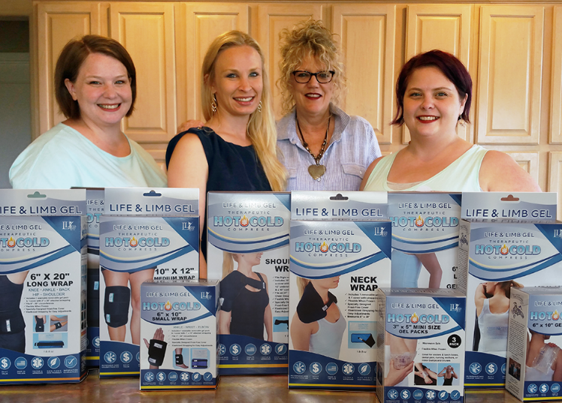
From Our Family To Yours…

Thank You

For Your Business

Starting off on a shoestring budget in a garage, Life and Limb Gel has humble beginnings. Chelsea Frank once worked as a prosthetist / orthotist, making artificial limbs and customized braces. She discovered a passion for inventing when she came up with a unique shoulder brace and risked "Life and Limb" by taking her creative vision to a new level with Life and Limb Gel.
Starting small allowed her time to get her business and products perfect using superior quality USA materials and exceptional designs. Using 7 years of customer feedback, Life and Limb Gel has fine-tuned their products to perfection. Life and Limb Gel is now a leader in the hot and cold therapy industry, priding themselves on excellent customer service, quality craftsmanship, and affordable prices.

®

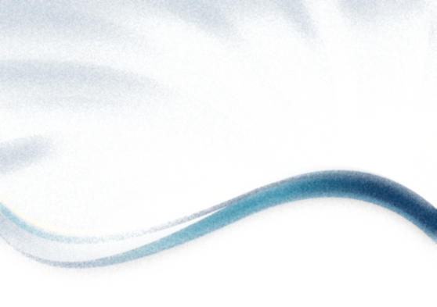
®

Product Name | SKU | Wholesale | Quantity | Line Total
Neck Wrap | 201206 | $10.00
Head Wrap | 201803 | $6.00
Extra Small Wrap | 201807 | $6.00
Small Wrap | 201208 | $9.50
Medium Wrap | 201204 | $15.00
Large Wrap | 201201 | $19.00
Long Wrap | 201202 | $15.00
3” x 5”  X-Small Gel Packs | Three Pack – 201339 | $3.50
 | Six Pack – 201339 | $6.00
6” x 10”  Small Gel Pack | Single Pack – 201318 | $3.50
 | Double Pack – 201328 | $6.00
10” x 12”  Medium Gel Pack | Single Pack – 201314 | $5.50
 | Double Pack – 201324 | $ 9.00
6” x 20”  Long Gel Pack | Single Pack – 201312 | $5.50
 | Double Pack – 201322 | $9.00
LIFE AND LIMB GEL
WHOLESALE ORDER FORM

Free Shipping on orders over $400.00 TOTAL:

Web: www.lifeandlimbgel.com
E-mail: info@lifeandlimbgel.com
Phone: (360) 909-2845
Fax: (503) 419-9871
Mail: 399 S Razor Clam Drive SW
Ocean Shores, WA 98569
Revolutionary Hot & Cold Therapy
Life & Limb Gel

®

WHOLESALE ORDER FORM

Place your order by phone, fax, e-mail, or at www.lifeandlimbgel.faire.com . Minimum order: $200.00 (Only $100.00 online) Subsequent Minimum: $100.00. We accept checks, PayPal, and Credit Cards. 60 day terms available online. Arrange pick-ups with a carrier of your choice or we will ship using the most cost-effective method available. Buyer will be responsible for shipping fees. Lock in FREE shipping for a year online. We normally ship orders within 48 hours of receiving payment. Some instances may require more time. We offer our customers a 1-year warranty and accept returns on any damaged or incorrect goods. We will honor any returns to our retail locations and take responsibility for any shipping charges necessary.

Date:___________________________ _________ Purchase Order #_________________
Buyer Name:___________________ ________ Tax ID: _________________________
E-mail Address:_____________________________________ Phone:_________________________
Delivery Address:___________ _________________________________________________
Billing Address (If Different):______________________________________________________________

Payment Method: Check PayPal Credit Card
CC#_______________________________________________ Expiry:____ _____ / ___________
Code:___________ Signature:____________________________________________________________
Notes:________________________________________________________________________________
_____________________________________________________________________________________

®

Life & Limb Gel
Revolutionary Hot & Cold Therapy

Web: www.lifeandlimbgel.com
E-mail: info@lifeandlimbgel.com
Phone: (360) 909-2845
Fax: (503) 419-9871
Mail: 399 S Razor Clam Drive SW
Ocean Shores, WA 98569

